Suppose you have a travel agency. Do the following:

1. In the main page put the name of the Agency in a large font in the center of the page with a suitable background.
2. Insert a simple menu as follows:

|  |  |  |
| --- | --- | --- |
| About us | Gallery | Registration |

Select a color for the menu (background)

* Don’t put borders
* Try to use “html layouts” lesson to improve the layout of your pages.
* Once the user passes over (about us or Gallery or Registration) the color of the background should change.
* Once the user click on the area of About us he should be moved to another page that give a description about the agency.
* Once the user clicks on the area of Galley he should be moved to another page for pictures and videos. The page should have at least two DIVs. Each DIV contains information about a popular city or country + photos + YouTube videos for it. (you should take care about the way you present the information in the gallery).
* Once the user clicks on the registration area he should be moved to a form to fill his information. The form should contain the following information:

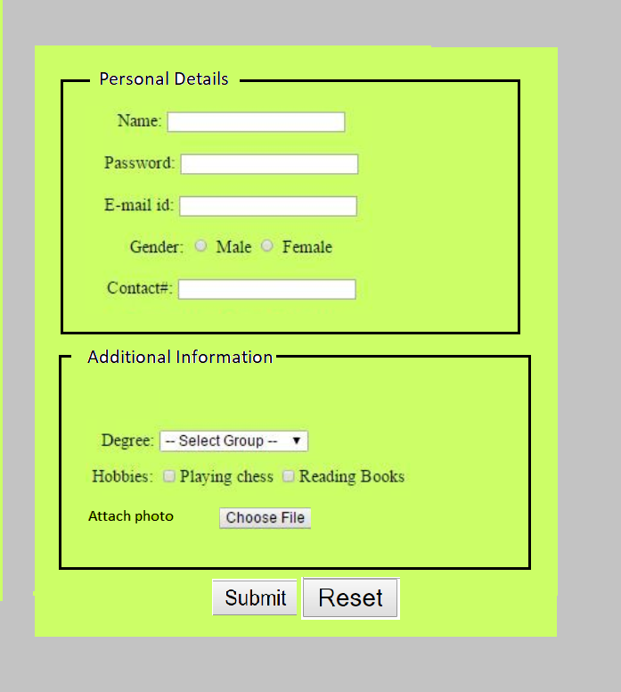

* Put placeholder for all the text fields.
* Keep the menu appearing in all the pages in the same place. Example:

Add a bloody text shadow

